Attachment A - Scope of Work
Kokee Firebreak Maintenance FY26/27

Solicitation Posting | December 10, 2025
Pre-Bid Meeting (On site) | December 17, 2025
Deadline to submit written inquiries | December 31, 2025
DOFAW’s Response to Written Questions | December 31, 2025
Deadline to Submit Bid* | Jan 9, 2025

SCOPE OF WORK (SOW)
The goal is to disrupt the horizontal continuity and vertical arrangement of fuels by creating a masticated fuel break along the ridge roads located within Puu Ka Pele and Na Pali Kona Forest Reserve. This will facilitate more effective fire prevention, pre-suppression, and suppression efforts. See attached map (Figure 1). The project area is owned and managed by the Department of Land and Natural Resources, Division of Forestry and Wildlife (DLNR DOFAW).
- Approximately 42,000 meters of roadside vegetation may be masticated in TMKs 120010070000, 120020230000, 140010140000, 140010130000, and 140010020000 The State will contract on a per meter treated basis, with both sides of the road being masticated 20’ on each side.
- Masticate all vegetative materials, smaller than 12” DSH (Diameter at Standard Height), within the project area, where practical and safe, using specialized heavy equipment with a masticating head attachment (see equipment requirements below). Using this specialized equipment increases work production and improves the overall safety of the project by minimizing the exposure time individuals are subjected to such hazardous working conditions. Contractor will be housed in a closed environmentally controlled cab unit.
- Tree stump heights shall not exceed 1’ in height measured from the high side of slope.

Portions of the project area may not be treated due to terrain or avoidance of sensitive features, such as the identification of endangered plants and/or endangered seabird burrows. The State reserves the right to purchase larger or smaller quantities at the per meter price quoted on the OFFER FORM page.
Initial contract term is [one (1) year], with the option for the State to extend the contract for up to additional one (1)-year period under the same terms and conditions, subject to the availability of funds and mutual written agreement.
Access:
(Incidental to Work)
A - Purpose & Applicability
This section applies to all access along existing roads and trails used to reach the treatment units described above. This is incidental work necessary to complete the fuels reduction and does not authorize capital road improvements.

B - Allowed Incidental Activities
The Contractor shall perform only the minimum access work needed for safe passage and to prevent resource damage, which may include:
- Removing small windfalls and debris blocking the route.

- Spot-filling ruts and potholes with on-site native material; light blading to restore drainage.

- Installing temporary drainage features (water bars/rolling dips) and temporary matting as needed.

- Limited spot rock placement only with written approval of the Owner’s Representative.

Prohibited activities: new road construction, re-alignment, widening beyond existing prism, ditch/shoulder reconfiguration, culvert installation or replacement, aggregate surfacing (unless material is already pre-positioned on site), or other capital improvements.
C - Planning & Approval
Before starting access work, hold a joint field review and submit a brief Access Plan identifying anticipated incidental tasks, any temporary measures, and materials to be imported (if any). Written approval is required prior to importing materials or deviating from mapped roads/trails.
D - Environmental & Resource Protection
Respect all sensitive resources and avoidance flagging indicated in the SOW (pink/black stripe). Use only designated crossings; do not disturb wetlands/streams or cultural sites.
Vegetation larger than 12" DBH shall remain standing and undamaged per the SOW.
E - Seasonal/Operational Limits
All access and fuels work shall comply with the SOW’s window restrictions (no mastication of trees taller than 15’ shall occur between June 1–September 15, 2026, due to bat pupping season). If Contractor would like to continue mastication of trees taller than 15’ during this period, they must hire their own wildlife biologist to survey trees. The Owner’s Representative may suspend access during saturated conditions, excessive rutting, or elevated fire danger.
Trail roads 1-6 are locked and only open on legal hunting days. Contractor will be issued a key for the gates for the duration of the project. Gates shall be left how they are found.
Work shall not occur on public hunting days (Weekends and State Holidays), without prior approval from DOFAW.
F - Road Condition Documentation
Complete a pre-work joint photo log of existing access route conditions prior to mobilization and a post-work photo log at closeout. Photos shall geo-reference key locations (gates, junctions, problem spots).
G - Restoration & Closeout
Upon completion, remove temporary measures not intended to remain, pull berms as needed for drainage, smooth/scarify rutted areas, stabilize disturbed soils, and leave roads in equal or better condition than at the start, considering seasonal moisture.
H - Protection of Improvements
The Contractor is responsible for repairing damage to existing roads, gates, signs, and drainage features caused by its operations, excluding normal wear and pre-documented pre-existing conditions.
I - Measurement & Payment
Incidental access is subsidiary to the fuel reduction items; no separate payment will be made.
Terrain:
The project area contains some steep roads and slopes. Roads are 4wd dirt and can be extremely slick during the wet season.

Weather:
Weather conditions at the sites are at times extreme and may change rapidly. Therefore, the work activity is weather contingent, and the Contractor must have a flexible schedule and be able to respond when weather conditions allow access.
Special Conditions:
- Work will be allowed on weekdays and weekends, during daylight hours only with prior approval from DOFAW.
- Contractor shall be held liable for any damages to the existing roads.
- Contractor shall be held liable for any wildfires due to his/her negligence. At a minimum, a shovel and fire suppression apparatus with 300+-gal storage capacity shall be present in the area while conducting this activity.
- Contractor will be responsible for any damage to any improvements in the area, including existing county water lines, fences, and gates, poles, and telephone lines.

Site preparation:
The project area will be delineated and flagged orange by DOFAW with pink and black stripe flagging will indicate a T&E species is present and shall be avoided.
All sites will be flagged and avoided. If the Contractor finds bones or cultural artifacts at any time during site preparation or installation, work must immediately cease and DOFAW notified immediately. The State has conducted biological surveys and has flagged all known rare species locations. Contractor will be responsible for not damaging those resources. All human litter and waste must be removed from the site at all stages of the fire break maintenance.
Camping:
All Special Use Permits permitting camping during the project period must be in hand prior to the commencement of work. Camps along the ridge roads will be permitted subject to approval in advance by the Kauai District DOFAW office in accordance with standard guidelines for camping in State Forest Reserves. DOFAW staff will coordinate with the Contractor on appropriate camping locations. All human trash, waste and refuse must be removed from the area. Contractor must state this in their bid and describe the steps they will take to remove the human waste from the area.
Native and Alien Plants and Animals:

The purpose of this project is to the reduce the fuel load throughout Puu Ka Pele and Na Pali Kona Forest Reserve Ridge Roads, State Parks Access Roads, Kekaha Game Management Area Roads, as well as Department of Hawaiian Home Lands Roads. Native plants over 12’ DSH and/or animals may not be removed or masticated in the project site. The Contractor will implement precautions to prevent the introduction of alien plants, animals and insects. Boots, equipment, and materials will be cleaned and inspected by the Contractor for seeds, eggs, larvae, etc., special care to sanitize material prior to site placement must be taken. All precautions and protocol pertaining to RAPID OHIA DEATH (ROD) must be followed. NO EXCEPTIONS. All equipment, field gear, and personal belongings must be cleaned and sanitized to prevent the transmission of Rapid Ohia Death (ROD) or other forest pathogens. ROD sanitation treatments must occur every time the contractor leaves the area and returns to the project area. The Contractor will also take precautions to prevent spreading alien plants already found at the fuel reduction sites. The use of any field gear previously used on Hawaii Island, is prohibited on Kauai Island. The Contract Administrator reserves the right to inspect all gear prior to deployment to ensure cleanliness. The Contractor will remove all food, refuse (including human feces), tools, gear, and any scraps brought into the area upon completion of work at each fuel reduction site.

Rapid Ohia Death (ROD) Sanitation Requirements:

The overarching protocol for preventing the spread of ROD on Kauai is currently to avoid using clothing, footwear and other equipment that has been used in potentially ROD-infected areas. Staff or volunteers conducting contract work on State lands or managed areas will not use any items (articles of clothing, boots, backpacks, tools, etc.) that have not passed a thorough sanitation process. Gear and equipment will be accompanied with a sanitation record that may be requested on site and as such must accompany the contractor and or their staff when conducting the work. Because of the known presence of Ceratocystis huliohia and C. lukuohia on Hawaii island, the use of any field gear previously used on Hawaii Island, is prohibited on Kauai Island. Extra care should also be taken for all gear, to prevent the spread of invasive plants, animals, and pathogens as follows.

Additional care should be taken to limit injuries or wounding of standing ohia within the project area, including branches, trunks and roots, as these sites are known to be susceptible to ROD infection. All mastication blades should be maintained to be as sharp as practicable to produce thicker wood chips/sawdust when cutting ohia is required, as this can reduce the possibility of spread of spores or infected material between trees, if a tree along the fence route is already infected. Suspect ohia trees (recently dead or dying branches or trees, with brown to reddish leaves still attached, or with obvious beetle damage) should be photographed and communicated to DOFAW and avoided until evaluation, testing and/or proper treatment can occur. In the event of an inadvertent injury to a standing, healthy ohia, Contractor should apply commercially available pruning seal (brand name Spectracide) to any large or obvious open wounds to trunk or roots of trees to protect against ROD infection - Spectracide will not be furnished by the state but is inexpensive and commercially available in many local stores.

Communication:
DOFAW recognizes that the contractor may not work on the job continuously from start to finish. At the same time, DOFAW and the leasee have management responsibilities to the parcel that must be coordinated around the fuel treatment schedule. Thus, contractor shall notify DOFAW and the leasee at least five (5) days in advance whenever work at the job site is planned to begin and shall notify DOFAW within three (3) days of leaving the job site if the contractor plans to be away for more than one (1) week. All Special Use Permits permitting camping sites use must be acquired at the Kauai DOFAW Office prior to the commencement of work.
Project Completion:
The Contractor will remove all equipment, tools, and trash.
SPECIFICATIONS/REQUIREMENTS
The following specifications are necessary to ensure that the mastication work goes as planned with limited number of delays and/or setbacks.
Vendor is required to:

- Provide proof of A License (General Contractor) or C-27-b License
- Provide proof of Commercial Liability Insurance listing the State of Hawaii as additional insured. Coverage amounts of $1,000,000.00 per occurrence and $2,000,000.00 per aggregate.
- Provide performance bond for the processing of a Purchase Order.
- Provide proof of two (2) past projects/jobs completed within the last five years that were 10,000 meters or more of similar type work.

Equipment Requirements:

      - Vertical mulcher: Fecon masticating head (mulcher). Must have a 10-pound fire extinguisher on board.
      - Horizontal mulcher: Fecon masticating head (mulcher). Must have a 10-pound fire extinguisher on board.
      - On-site fire suppression apparatus with minimum of 300-gal storage capacity.

The Contractor shall be responsible for the provision of the necessary installation equipment, supplies, tools, and all labor required to complete fuels reduction project as specified herein. The Contractor shall be responsible to provide their own transportation of all materials, crews, equipment and supplies to the site.
Contractor is advised that DOFAW shall not supply communications equipment. The Contractor is advised that DOFAW shall not supply personal protective equipment (PPE).
The Contractor may not use the DOFAW baseyard as an office or staging area; for storage of tools, supplies, equipment, or other materials; or for overnight vehicle parking.

Timing of Project

Pre- Conference:

Contractor shall meet with staff from DOFAW soon after the award, if any. Topics to be included at the meeting will be:
- Designation of responsible officials
- Correspondence procedures
- Labor standard provisions
- Changes in specifications
- Payments to the Contractor
- Safety program
- ROD Sanitation SOP
- Communication
- Proposed work schedule
- Camping guidelines and restrictions
- Alien plants and animals’ precautions
- Miscellaneous

Written Inquiries
Inquiries regarding this solicitation are due no later than the date indicated in the timeline. Inquiries shall be made in writing by e-mail to: scott.d.nelson@hawaii.gov. The State will respond to questions in writing by the date indicated in the timeline. Written inquiries received after the date indicated in the timeline may be responded to at the discretion of the State.

Specifications/Locations:
Mulch all non-native vegetation smaller than 12” diameter 20’ on both sides of identified sections in attached map. Flagging in pink/black striped will mark trees and areas to avoid should endangered plants be found. This information will be known to contract prior to start of the contract.
Vegetation larger than 12” diameter can remain standing but undamaged to ensure the tree remains healthy and standing. If too much damage occurs to nearby standing trees they may die slowly and become hazardous in the near future.
Work shall not occur between June 1 and September 15, 2026, due to bat pupping season. If Contractor would like to continue mastication of trees taller than 15’ during this period, they must hire their own wildlife biologist to survey trees.
Bid must include equipment and attachments contractor will use.
Bonding requirement applies. Bid bond and Performance bonds required.
Insurance requirement applies.

Total proposed length is 42072 meters or 26.3 miles.
There are seven identified Sections, below are some descriptions for the sections. Note GPS locations are provided in Lat/Long and UTM 4Q coordinates and marked with orange flagging. (Shown in yellow lines on map)
Final sections to be determined by DOFAW based on bid prices and availability of funds
Line Item 1:
Section 1
- Trail 1, section begins at the gate to enter the road right off Highway 550 between mile markers 9 and 10 and ends at the top gate to enter the Kekaha Game Management Area.
- 6000 meters (3.7 miles)

- Starting 22.062142 x -159.665225 // 431363.76 x 2439854.90 (no picture available)

- Ending 22.034007 x -159.703317 // 427419.03 x 2436758.19 (no picture available)
Section 2
- Trail 3, Haeleele Ridge Road section begins at the gate below Contour Road and ends at the end of the road.
- 3861 meters (2.4 miles)

- Starting 22.087120 x -159.687163 // 429112.63 x 2442629.82

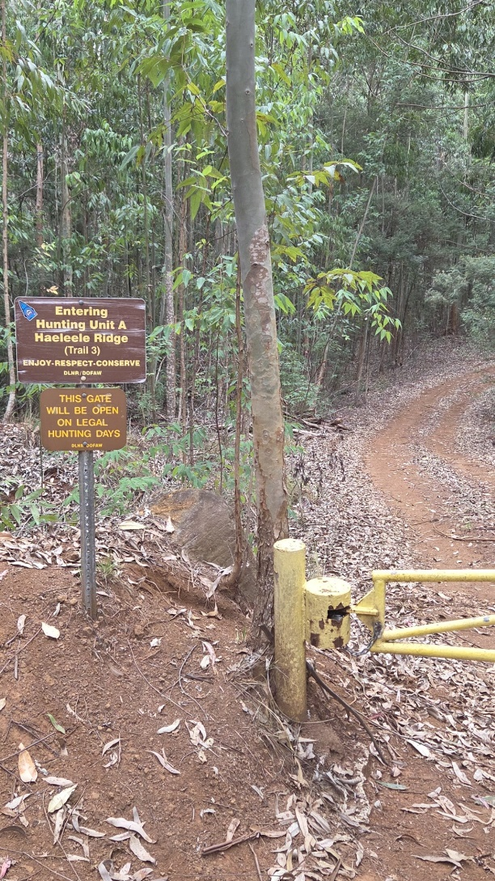

- Ending 22.087887 x -159.734052 // 424275.81 x 2442737.28 (no picture available)

Section 3
- Trail 4, Polihale Ridge Road section begins at the gate after Contour Road and ends at the end of the road
- 5631 meters (3.5 miles)

- Starting 22.093923 x -159.689438 // 428881.34 x 2443383.92

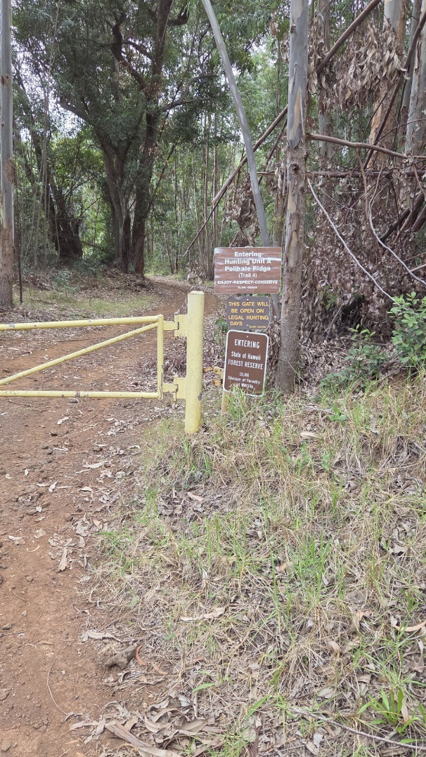

- Ending 22.096372x -159.735548 // 424126.03 x 2443677.26 (no picture available)

Section 4
- Trail 5, Kaaweiki Ridge Road section begins at the first gate immediately below Contour Road and ends at the end of the road.
- 5792 meters (3.6 miles)

- Starting 22.103708 x -159.689955 // 428828.79 x 2444467.31

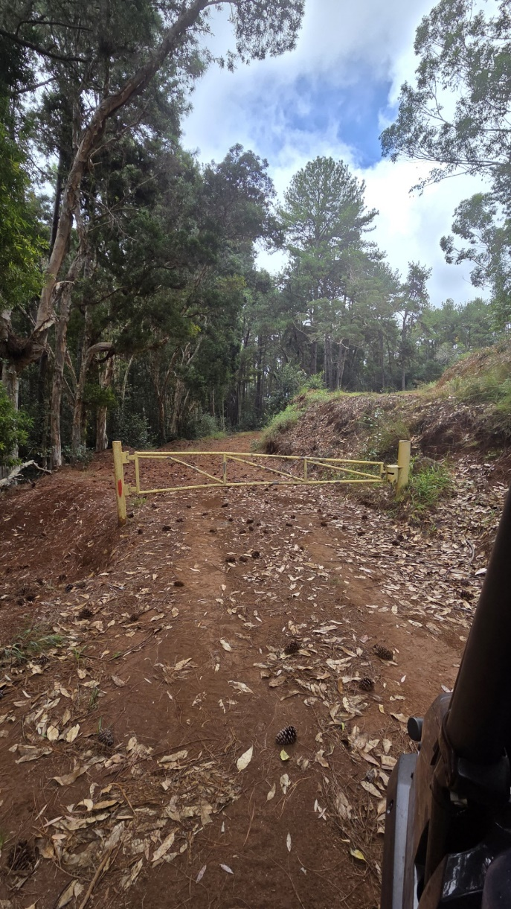

- Ending 22.105289 x -159.737941 // 423883.94 x 2444665.51 (no picture available)

Section 5
- Trail 6, Kauhao Ridge Road section begins above Contour Road near the border of State Parks and DOFAW managed land and ends at the end of the road.
- 5953 meters (3.7 miles)

- Starting 22.107912 x -159.686459 // 429195.63 x 2444931.02
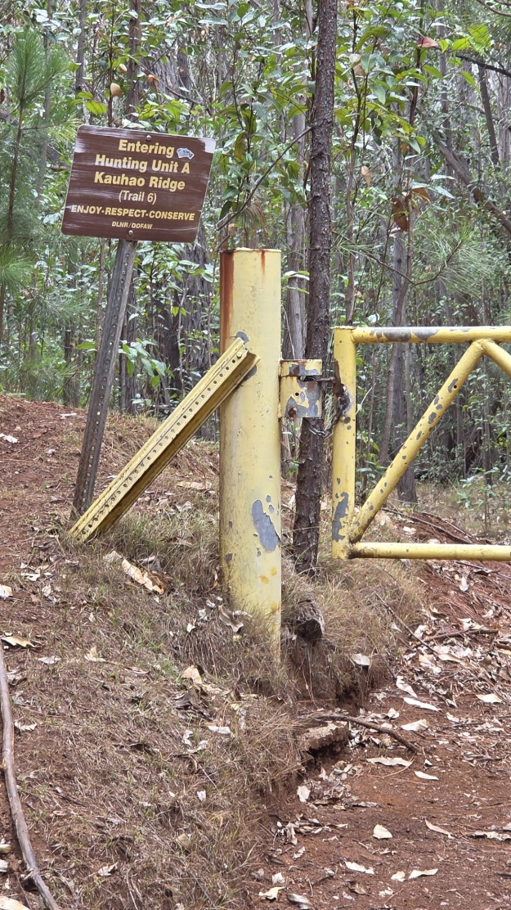

- Ending 22.114894 x -159.733387 // 424358.81 x 2445726.46 (no picture available)

Line Item 2:
Section 6
- Makaha Ridge Road begins at the junction of Makaha Ridge Road and Highway 550 and ends at the entrance to the Pacific Missile Range Facility.
- 6515 meters (4.1 miles)

- Starting 22.113036 x -159.670889 // 430804.14 x 2445491.05 (no picture available)

- Ending 22.129615 x -159.722190 // 425521.45 x 2447350.46 (no picture available)
Line Item 3:
Section 7
- Milolii Ridge Road begins at the junction of Makaha Ridge Road and ends at the end of the road.
- 8320 meters (5.2 miles)

- Starting 22.113829 x -159.672984 // 430588.45 x 2445579.78 (no picture available)

- Ending 22.141603 x -159.720237 // 425729.15 x 2448676.51 (no picture available)

